C-50
无人机捕捉网规格书
Drone Capture Net Specification

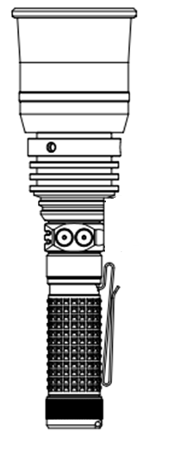

✹产品介绍INTRODUCTION
C-50是一款轻便、便携的无人机捕捉网，在节能模式下可运行长达600小时。它由一块可更换的21700（4500mAh）锂离子电池供电，可通过机身上的USB-C端口充电，仅需3小时即可完全充满电。尾盖采用磁性设计，可安全地固定在金属表面上。M5的设计适用于各种场景的多功能使用。
The C-50 is a lightweight, portable drone capture net with up to 600 hours of operation in energy-saving mode. It's powered by a single, replaceable 21700 (4500mAh) lithium-ion battery, rechargeable via the onboard USB-C port and fully charged in just 3 hours. The tail cap features a magnetic design that securely attaches to metal surfaces. The M5 is designed for versatile use in a variety of scenarios.
✹包装内容PACKAGE CONTENTS
手柄组件x1，充电线x1，捕获网组件x2，用户手册x1。
Handle assembly x1, charging cable x1, capture net assembly x2, user manual x1
✹预防措施
如果产品长时间未使用，请取出电池。
避免直接将C-50喷洒到人或动物身上。
如果产品未密封且未固定，应将其放置在远离潮湿环境的地方，以防止湿气接触到内部的电子元件。
请勿自行拆卸设备，因为这可能会损坏无人机的捕捉网。
请使用标准、经过安全认证的5V充电器进行充电。标准的手机充电器也可以使用。请使用输出电压不超过5V的充电器。

If the product is not in use for an extended period, remove the battery.
Avoid spraying the C-50 directly onto people or animals.
If the product is not sealed and secured, keep it away from humid environments to prevent moisture from reaching the internal electronic components.
Do not disassemble the device yourself, as this may damage the drone's capture net.
Please use a standard, safety-certified 5V charger for charging. A standard mobile phone charger will also work. Use a charger with an output voltage no greater than 5V.
✹尺寸SIZE

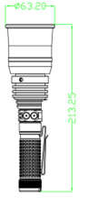

强磁铁Tail Magnet

触发按键Trigger Button
主开关按键
Main Button

夹子Clip

主开关操作Main switch operation

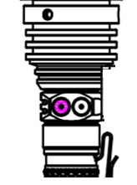
长按开启Press and hold

主电源按钮有一个锁定按钮。在锁定状态下再次按下该按钮将不起作用。
长按主电源键超过两秒即可解锁（解锁后指示灯将保持点亮状态）。如果在解锁后两分钟内没有动作，该按钮将自动锁定。
The main power button has a lock button. Pressing it again while locked will not work.
Pressing the main power button for more than one second will unlock it (the indicator light will stay on after unlocking). If there is no movement within two minutes after unlocking, the button will automatically lock.

击发无人机捕捉网 Firing Drone Capture Net

长按 开启Press and hold

击发Firing

注: 长按主按钮两秒以启动无人机的捕捉网。
（安全提示: 请务必牢牢握住把手， 因为强大的反向推力可能会造成伤害。）
Note: Double-click the main button twice to launch the drone's capture net.
(Safety Tip: Make sure to hold the handle firmly, as the powerful back-thrust force could cause injury.)

产品尺寸 | 产品重量 | 工作温度 | 有效射程 | 出网面积
214*64毫米 | 480克 | -30-60摄氏度 | 40-50米 | 4-9平方米
注意：有效射程会因为发射角度、风阻等原因有一些变化！！！

SIZE | WEIGHT | TEMPERATURE | EFFECTIVE RANGE | AREA
214*64MM | 480 G | -30-60 | 40-50 M | 4-9 Square Meters
Note: The effective range may vary due to factors such as launch angle, wind resistance, etc.!!!

特别提醒：

1. 本品须严格按说明书指导使用。
2. 请遵守国家相关法律法规，严禁喷射人或动物。
3. 因违反使用说明或法律规定导致的一切损失，均由使用者自行承担，我公司不承担任何法律责任。

Special Reminders:
1. This product must be used strictly in accordance with the instructions.
2. Please comply with relevant national laws and regulations. Spraying on humans or animals is strictly prohibited.
3. Any losses resulting from violation of the instructions or legal provisions are the sole responsibility of the user. Our company assumes no legal liability.

